VAST Course report - Hyderabad, India

25 Feb – Mar 1 2019

Dr Adam Mossenson

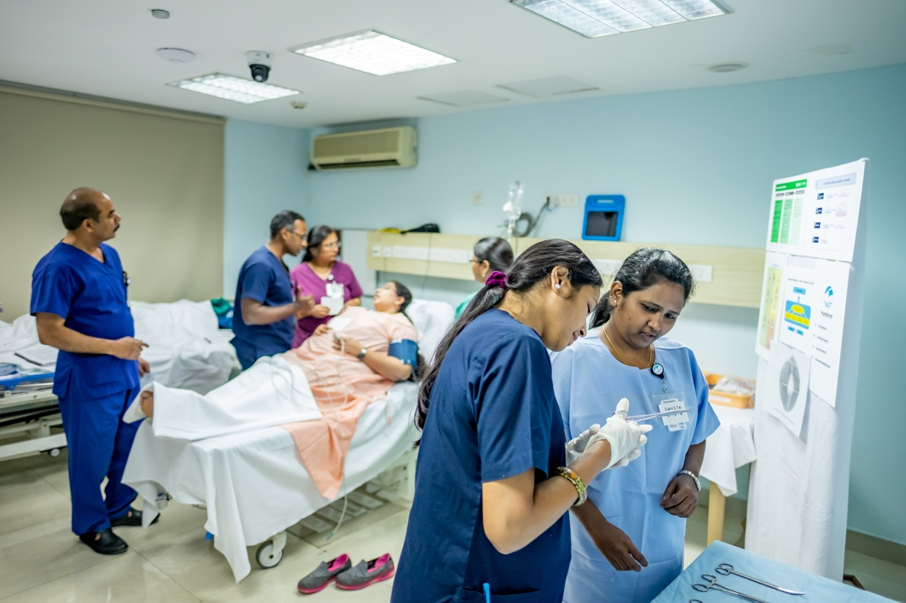

Executive summary

Situation

VAST and its associated Facilitator Course (VAST FC) were successfully delivered for the first time in Hyderabad, India in late February 2019.

Background

VAST was developed as a collaborative project between partners in high and low-resource countries and was piloted in Rwanda, January 2018. VAST uses immersive, low-fidelity simulation and covers core aspects of safe anaesthesia delivery, with a specific focus on non-technical skills. The Course underwent revision following the pilot and this most recent Course in Hyderabad represents the first time VAST has been delivered with the financial support of the WFSA and its funding partner Massimo. Given the time constraints of international and local faculty, an adapted two-day VAST FC preceding the three-day VAST Course. In total, 6 trainee facilitators attended the VAST FC and 16 participants the VAST Course.

Assessment

Both the VAST Course and its associated VAST FC were exceptionally well received. Whilst medical education and the standard of anaesthesia delivery in Hyderabad in advanced in comparison to low-resource settings, simulation represented a new platform for education for the majority of course participants. Course content was applicable and relevant in this context. The multidisciplinary nature of the simulation groups was a great asset in both scenario delivery and debriefing. There is a great thirst for ongoing VAST Courses and simulation-based training more broadly in India. Trainee-facilitators developed greatly over the week, however, ongoing mentorship and skill development is required before their reaching of independence in simulation delivery.

Recommendation

The overwhelmingly positive reception of VAST in Hyderabad and desire for further simulation-based training supports planning future courses. VAST was able to engage multidisciplinary learners and simulate realistic team dynamics; all future course should continue to strive for participants of mixed clinical backgrounds (i.e. anaesthesia, nursing, midwifery and surgery). Ongoing development of trainee-facilitators must occur following a set of courses. The encouragement of practising debriefing in their workplace, engagement with and ongoing mentorship by international facilitators on future VAST Courses will help hasten the development of the local capacity for simulation delivery and sustainable future delivery.

Contents

Course background | 3
Faculty and attendees | 3
Venue and equipment | 4
Summary of evaluations | 4
Challenges and lessons learnt | 5
Post course follow-up | 6
Future directions | 6
Appendix I – evaluations | 7
Appendix 1I – course photos | 11

Course background

Since its inception, VAST has been a project endorsed by the WFSA. To date, previous VAST Courses have sourced funding from other agencies and institutions. The delivery of VAST in Hyderabad represents the first WFSA funded VAST Course. The external donor was Massimo. Essential to the planning, delivery and sustainability of VAST is a country coordinator or ‘local champion’. The WFSA chose wisely in the appointment of Dr Gita Nath as VAST Telangana coordinator. Dr Nath seamlessly coordinated the venue, participants, was instrumental in course logistics as well as being an integral member of the trainee-facilitator group. A conscious decision was made to recruit senior clinicians and academic staff for the inaugural VAST course; the purpose was promote ‘buy-in’ to the program from the top-down. In addition, there was engagement with the local chapter of the Indian Society of Anaesthesiologists (ISA) and the Indian Association of Paediatric Anaesthesiologists (IAPA) and a welcome dinner was organised for all parties involved in the course.

Faculty and attendees

International faculty:
- Dr Adam Mossenson (Australia), specialist anaesthetist, VAST Founder and Managing Director
- Michelle Murray (Canada), nurse simulation specialist
- Dr Anna West (Australia), specialist anaesthetist
- Dr Tom Druitt (Australia), specialist anaesthetist

Observers:
- Amal Paonaskar (London), WFSA projects officer
- Giresh (India), Nurse at Care Institute of Health Sciences

Participants and demographic data:

Insert completed participant registration and demographic data form:

Venue and equipment

The Care Institute of Health Sciences (CIHS) was chosen as the location for the Course. The motivation for this was multifactorial, in part due to Dr Nath’s experience of running courses with CIHS and due to the relatively short preparatory time frame for course organisation. The venue proved to be an ideal space for running two parallel simulation groups, with isolated debriefing rooms, a large central discussion area an all the required IT to run VAST. In addition, Michelle took the opportunity to train Giresh (CIHS staff with a nursing background) in the processes of running a VAST Course. Giresh will be a great asset for the future delivery of VAST if there is an ongoing association with CIHS.

Equipment was predominantly supplied by CIHS. All simulation mannequins and nearly all other simulation equipment was provided. There were no specific paediatric mannequins, but as in previous courses, we made use of the adult mannequins for the paediatric scenarios. The visiting Faculty/WFSA provided all the of the VAST teaching materials, printing, iPads (4) and spare scrubs. A small surplus of VAST ID clips and aide-memoirs was also left. All of these resources were inventoried and left in the care of Dr Nath. For future course delivery there will need to be printing of VAST/VAST FC handbooks. Local printing of future course materials should be encouraged where feasible.

Summary of evaluations

VAST Course:

There was an appreciation expressed regarding both the technical components covered in VAST and the focus on non-technical skills. The supportive and organised approach of the faculty was widely appreciated. There was an overwhelming sentiment amongst the group that VAST should be offered on a rolling basis in Telangana and the Very VAST simulation curriculum (still under development) should be included into post-graduate anaesthesia medical education.

VAST Facilitator Course:

It was evident from the outset that simulation and non-judgemental participant lead debriefing was a radically different mode of medical education, even for this extremely experienced group of medical educators. The enthusiasm and drive to develop this new skill amongst the trainee facilitators was palpable. Two comments made during reflection at the end of day 2 of the facilitator course resonated deeply with the sentiments expressed in the formal evaluation forms (see appendix 2):

- “It is liberating to kno\w there is a different way of teaching”
- “Our students will never have experienced such kindness”

There was a strong desire amongst the trainee-facilitator group to be involved in future VAST Courses and more broadly to expand simulation-based education as a regular component of teaching in their institutions.

Challenges and lessons learnt

Take home messages:
- The VAST Course has a demonstrated applicability and utility for specialist anaesthetists in India
- Low-fidelity simulation can generate meaningful discussions and learning relating to core clinical practises and non-technical skills
- Delivery of VAST in region should be planned as a longitudinal initiative with multi-course funding to support the development of the VAST Network of facilitators and promote the local capacity for simulation-based education more broadly
- The VAST Facilitator Course can be adapted for use prior to the first VAST Course in a new setting for a group of senior educators with good command of the clinical content of VAST
- Ongoing mentorship, graded exposure and realistic goal setting regarding independence in facilitation is required following participation in the VAST FC
- Tailored and responsive delivery of facilitator training is a must

VAST Course:
This was a novel course in relation to the high calibre of the participants. Notwithstanding, the course content and focus on non-technical skills appeared to have great relevance and generated meaningful learning even for this group of senior clinicians. Future courses would however benefit from a more varied spread of anaesthesia providers, in particular to garner perspectives from anaesthesia trainees through to senior consultants. It was a real asset having nurses and surgeons as part of the simulation groups. The cases and clinical content were identified as reflective of their practice and did not need amending.

The need to build confidence and engagement of the nursing colleagues was acknowledged by all faculty. Each simulation group however only had one nurse, potentially isolating this participant and expecting them to represent all nurses opinions on a subject. As per our recommendations in the facilitator manual, ideally, each simulation group should have 2 nurses and a surgeon to combat this potential issue.

In the months preceding this course, there were repeated attempts to identify a suitable person to fill the role of simulation coordinator. This coordinator works to inventory equipment, setup and changeover the sim rooms and enable the facilitators to focus on the delivery of the sim and debriefing. Prior to the course, this person was not clearly identified. Michelle aptly trained Giresh (staff at the CIHS) in this role. Giresh’s ability to be part of ongoing VAST courses outside of CIHS are unclear. For future courses, someone with a clear affiliation with the VAST coordinator (i.e. Dr Nath), who can have assured ongoing association VAST should be clearly identified.

VAST FC:
Development of the local facilitator network, promoting sustainable course delivery and eventual handover is central to the design of VAST. We widely acknowledge in the VAST FC that the concepts of simulation are complex and development of skills in facilitation is a long journey; achieving independence in facilitation after only one course is an unrealistic goal for the majority of trainee facilitators. Even amongst this group of senior clinicians, the need for ongoing development in the skills of facilitation is clear. Going forward, an approach towards facilitator evaluation and competence assessment needs to be incorporated into training and mentorship.

Over the week, we emphasised to trainee-facilitators that there are many avenues for ongoing development of skills in debriefing, the more complex component of facilitation. All trainee-facilitators were strongly encouraged to regularly participate in teaching using the VAST debriefing framework in their clinical practice with the trainees and/or theatre teams. This can occur during routine clinical practice or following review of a critical incidence. In addition, there was a strong desire to plan another VAST Course to follow 3-6 monthly in order to consolidate skills.

Post-course follow-up

Following the course, electronic resources were shared with participants. These resources expand upon some of the key discussions and themes discussed throughout the Course. Course participants were also encouraged during the commitment to change workshop to keep a logbook of cases whereby their learning from VAST and new appreciation of non-technical skills impacted on patient care. We will endeavor to follow up participants in the months following the course to allow ongoing reflection and application of their new skills.

Future directions

Dr Nath has initiated the conversation regarding the future of VAST in Telangana. To quote from her follow-up email after the course, the key components that need to be considered are:
- Timing of the next course: We might want to have another course in 3-4 months time so that the skills we facilitators learnt can be reinforced. Maybe 2 external facilitators can come for this and we can also invite the participants we identified to be trained as facilitators so that we build up a base of enough facilitators to run future courses.

- Venue for the next course: The choice is between having it at CIHS versus doing it at a hotel. If we decide to do it at a hotel, we will need to procure all the equipment which was provided by CIHS – the cost will have to be calculated. Also, the back-stage help which was provided by Girish, Madhu, Dinesh etc will not be there.

- Costing: How many future courses will be financed by the WFSA? I understand that the Telangana project finishes at the end of 2020.

- Participants: I think we should start inviting trainees with at least 2 years anaesthetic experience as well as practising anaesthetists as participants for the course. So that we start doing what the course is meant to do, which is to improve crisis management and anaesthetic non-technical skills in practising anaesthetists.

Dr Nath has aptly highlighted the issues that need to be considered in the future planning of VAST in Telangana. Securing ongoing funding to sustainably support the delivery of the VAST Course is essential. In addition, it is our goal to support the delivery of simulation education more broadly and VAST will share its Very VAST simulation curriculum, supporting the delivery of longitudinal simulation in post-graduate anaesthesia education. Several members of the trainee-facilitator pool are in the position to institute this curriculum in their institution which will incorporate regular simulation to a large number of anaesthesia trainees. VAST has a long term vision for the incorporation of simulation design training for local simulation facilitators who have developed experience with VAST and wish to design tailor made simulation for their local context.

Appendix I – Participant evaluations

VAST Facilitator Course Feedback
Hyderabad, India, Feb 25 – 26, 2019

What did you like:
- Splitting the various steps of facilitation into stages and practising them
- Clear explanation
- Simulation was made easy to understand x 2
- Good focus on skill development
- Friendly and supportive facilitators x 2
- How to highlight protocols like SBAR and AMPLE
- Debriefing practice x 5
- Fun learning atmosphere x 3
- Good venue
- Involved everybody
- Course content
- Planning and teaching
- Appreciating the difference between conventional teaching and debriefing
- The importance of non-technical skills was made evident
- Enjoyed the conversation on colleagues who need support
- Realistic scenarios with minimal equipment

Suggestions for improvement:
- Make debriefing easier to understand
- Consider a skills session post lunch to keep us more alert
- More time to practice
- It would be easier to have done the facilitator course after having done the VAST Course first
- Continue to emphasise non-technical skills – there is very little NTS taught in India in a systematic way x 2
- Pocket cards to be made available for quick reference when debriefing
- Introduce participants on day 1 to the way of debriefing and facilitating to reach objectives of their own

What can you take away from the course:
- Depersonalise debriefing
- Observe non-technical skills and discuss them
- Keep clinical teaching to a minimum
- Non-threatening way of communicating
- Stay focused on the learning objectives
- Organised and streamlined way of doing things
- Self-reflective learning is the best way of learning and the facilitator needs to tailor it to the needs of the group
- Do your homework well before
- Importance of meticulous presentations
- Tips and tricks for debriefing
- Importance of debriefing x 2
- Importance of summarising and communication
- Focus on developing non-technical skills x 2
- Distil information during debriefing
- How to frame questions in the analysis phase
- How to facilitate without getting into the conversation
- Time management
- Participant driven take home messages x 2

Other comments:
- We had a fun learning time and did not feel stressed to learn new things x 2
- Its good to be part of facilitator training
- Keep up the good work
- This team is fantastic, just perfect
- The course could be a little longer – maybe 3 days to have more practice
- A little bit tiring – maybe because I had a lot of background things running in my mind other than VAST

VAST Course Feedback
Hyderabad, India, Feb 27 – Mar 1, 2019

What did you like:
- The debriefing method x 5
- Recognising the small gaps in communication that would probably affect patient outcome
- Committed faculty, ideal environment and space x 2
- Simulated case-based scenarios were realistic and relevant x 4
- Interactions in scenarios x 2
- Skilled teachers x 2
- Friendly learning environment x 5
- Involved every single candidate
- Fun to learn
- Group performance will give team spirit
- The concept of simulation is new to me
- Helping babies breathe plan x 2
- Pain management session x 3
- Difficult intubation sessions
- Encouragement of participation
- Team leader role
- Interactions with the rest of the team
- Importance of non-technical skills
- Very good and very helpful
- Group discussion will bring the best management
- Management of eclampsia patients
- Management of labour patients
- How to handle septic patients
- We learnt how to handle the patient and the critical situation
- Orientated to practical situations
- Everybody gets involved x 3
- Gained a lot of knowledge and skills
- Common clinical scenarios were discussed
- Team approach for task management
- No easy answers session
- A-E approach for emergency situations
- Demonstration scenario by the facilitators helped me understand the simulation better
- Trauma situations x 2
- Complex case scenarios and multitasking x 2
- Lots of improvement in communication with team members
- Efforts to create reality in the situations
- Management of burns

Suggestions for improvement:
- Nothing x 6
- More scenarios (feedback on day 1)
- More learning videos (audiovisual)
- Should be incorporated into the learning manuals at the postgraduate level x 3
- Provide hard copy of course materials ahead of time
- Organise some videos of simulation for day 1 to better understand the how to involve into the roles given to participants
- During debriefing, facilitators should share their views at the end x 2
- Improved models / level of simulation
- Facilitators should explain the importance of the take home messages
- If the demonstration (repeat) scenario was done on the first day it would have been better for us to understand simulation
- Continuous evaluation by attending these learning and refresher courses
- Continue these programs for helpful self-confidence and motivation

What can you take away from the course:
- How to manage pain
- Checklists are important x 9
- Patient safety is first. It can be improved with technical and non-technical skills
- Practice using protocols and guidelines
- Use good communication and team approach x 3
- Non-technical skills x 2
- We should implement debriefing after facing any critical event in day to day practise
- Every student must be exposed to all kinds of rare emergencies (in simulation) before they finish their post-graduation x 2
- Working as a team with good coordination reduces errors and stress x 2
- Simulation learning made us strong (less panic) during a real scenario
- Complete the surgical safety checklist
- Handover systematically x 2
- To avoid human error get team involvement
- Do not hesitate to call for help for safety of the patient x 2
- Patient counselling, reassure and support x 2
- Tackle hierarchy in your workplace x 2
- Prevent burnout in your colleagues x 2
- How to manage time
- Coordination of the team and multitasking x 5
- Prepare, preplan and prioritise in various situations x 6
- Assess, intervene but respect each other’s feelings
- Team work is a must x 2
- Communicate and call for help in a crisis x 4
- Professional respect and support colleagues x 2
- How to utilise resources
- Don’t create hierarchy situations x 2
- Don’t shift patients when unstable clinically
- Situational awareness with quick assessment and re-assessment
- Keep your eyes wide open
- Team leader should be assertive and allot specific tasks

Other comments:
- Organised well x 2
- We should conduct more simulation trainings to improve our skills
- Great way of learning new things
- It’s very helpful in crisis management to learn this systematic approach
- Great work
- It’s an effective way of teaching and learning
- Simulation is a powerful way of teaching
- Enjoyed the training x 2
- Training needs to be done more regularly
- Trainers are efficient and friendly
- Encouraging facilitators with good communication skills
- It is new and very informative in understanding the relevance and importance of non-technical skills and other important aspects like checklists, planning and executing the plan
- It was a wonderful learning experience. Thank you for including us and kudos to the team for a great workshop!
- All the facilitators and team from abroad were excellent, friendly with good commitment x 2
- Sessions were good in that they made us realise our backlogs
- Great job! Well designed course. Great new respect for teamwork

Appendix 1 – Course Photos

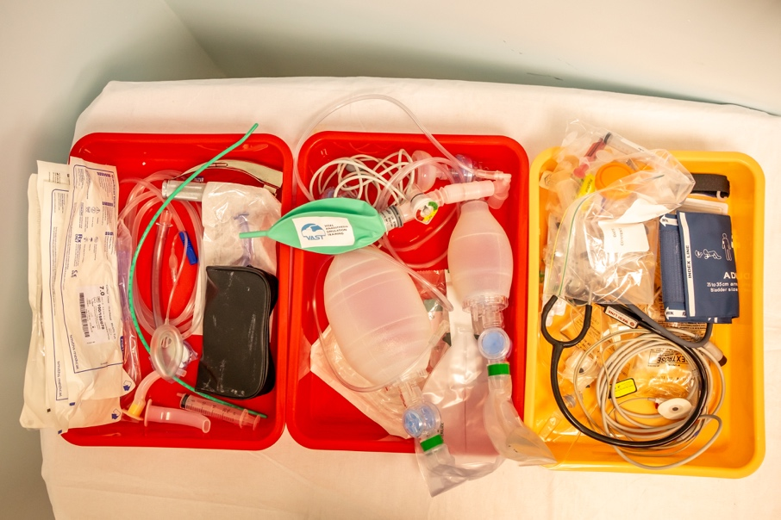
Standardised setup of equipment

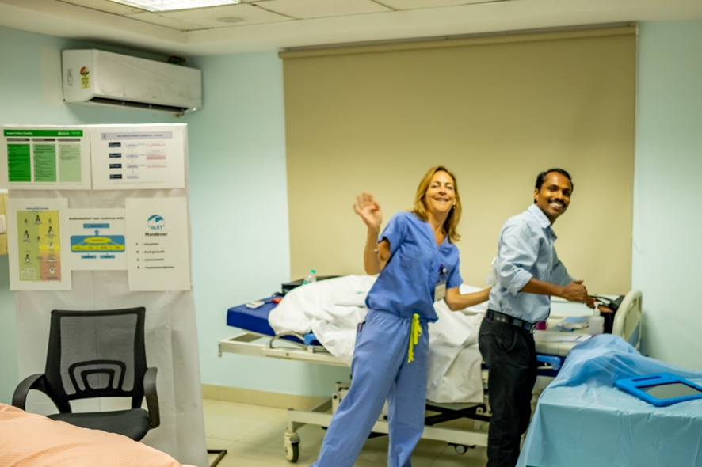
Michelle training Giresh on the ins and outs of VAST
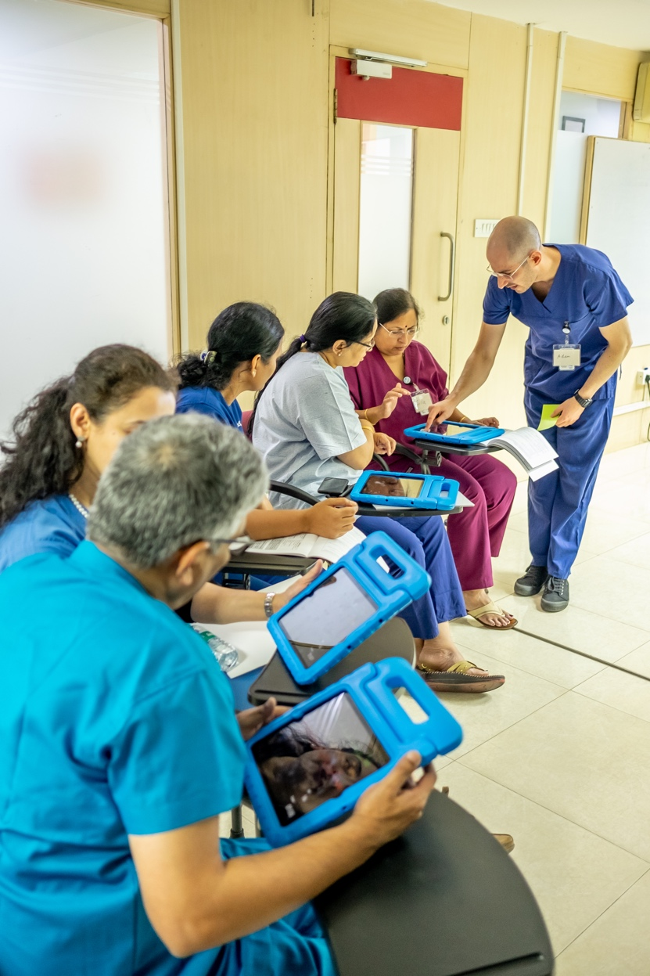
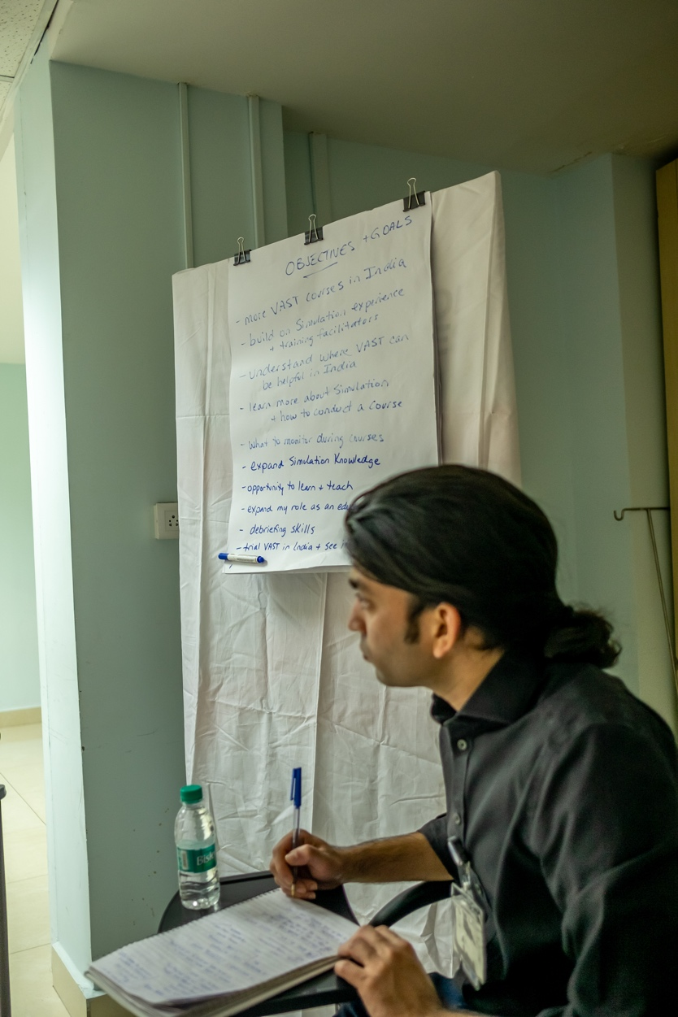

Amal dutifully taking notes Trainee facilitators first exposure to SimMon

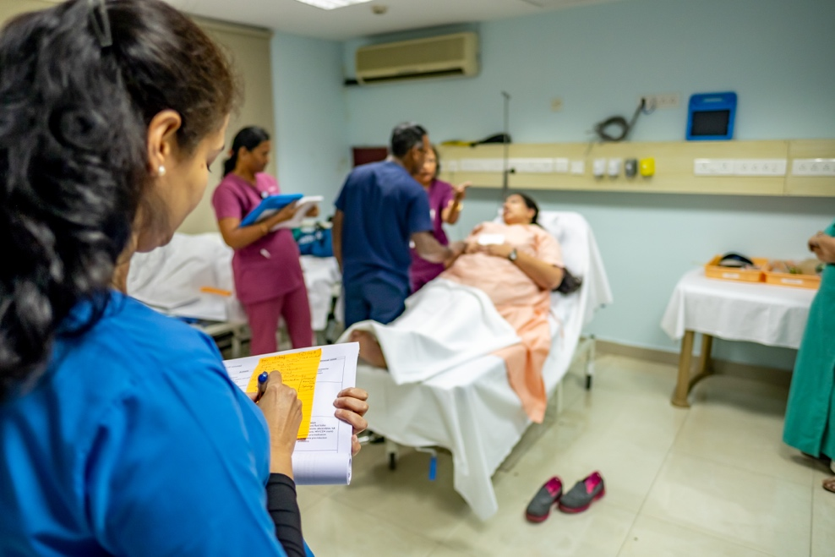
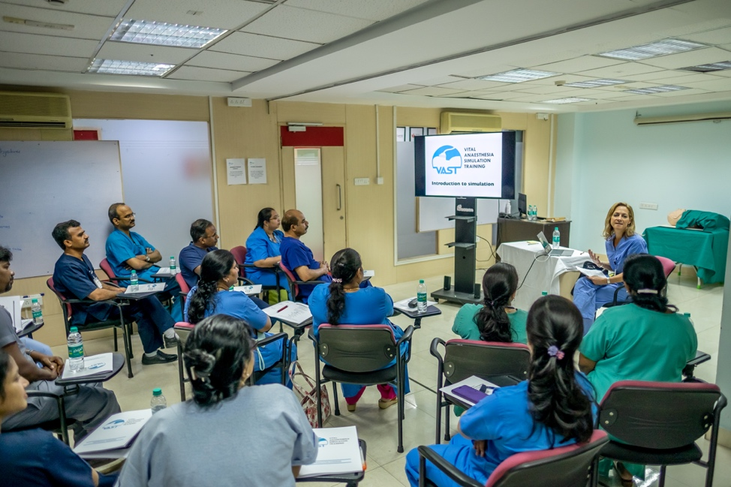

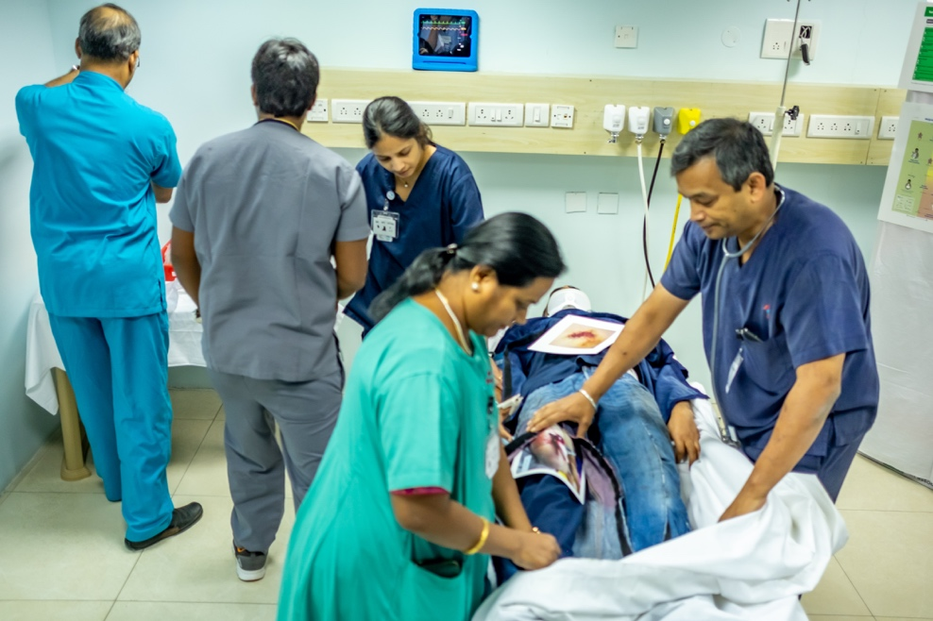
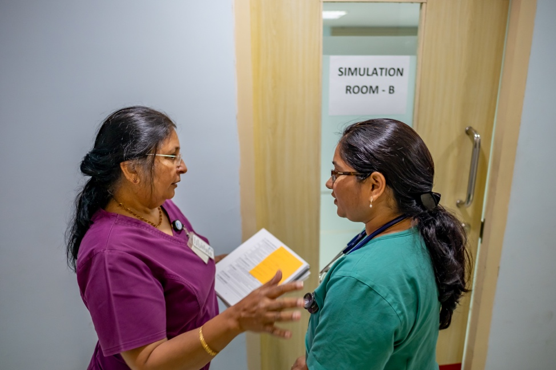

Top left: Michelle delivers the introduction to simulation to the group
Top right: Vai takes notes during an obstetric simulation in preparation for debriefing
Bottom left: Gita prepares the ‘lead participant’ outside the simulation room
Bottom right: Team response to a trauma victim
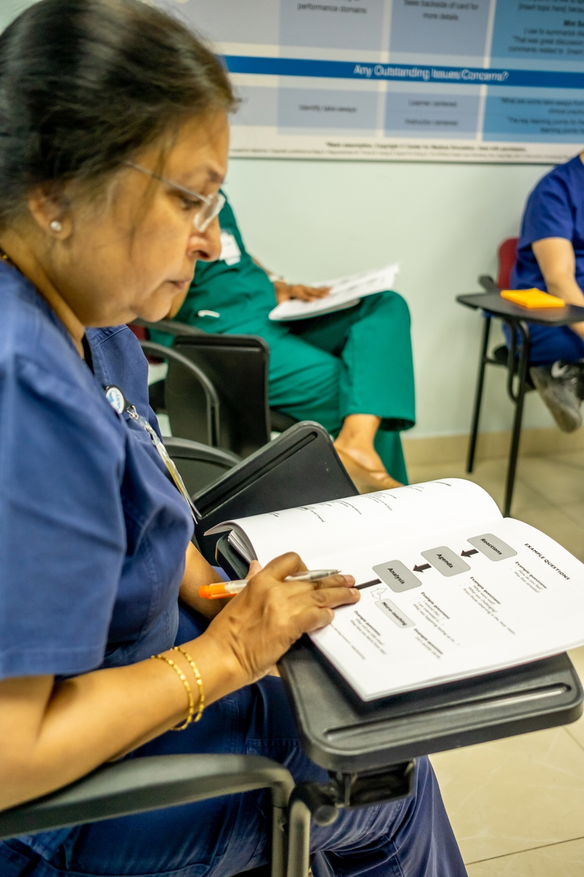

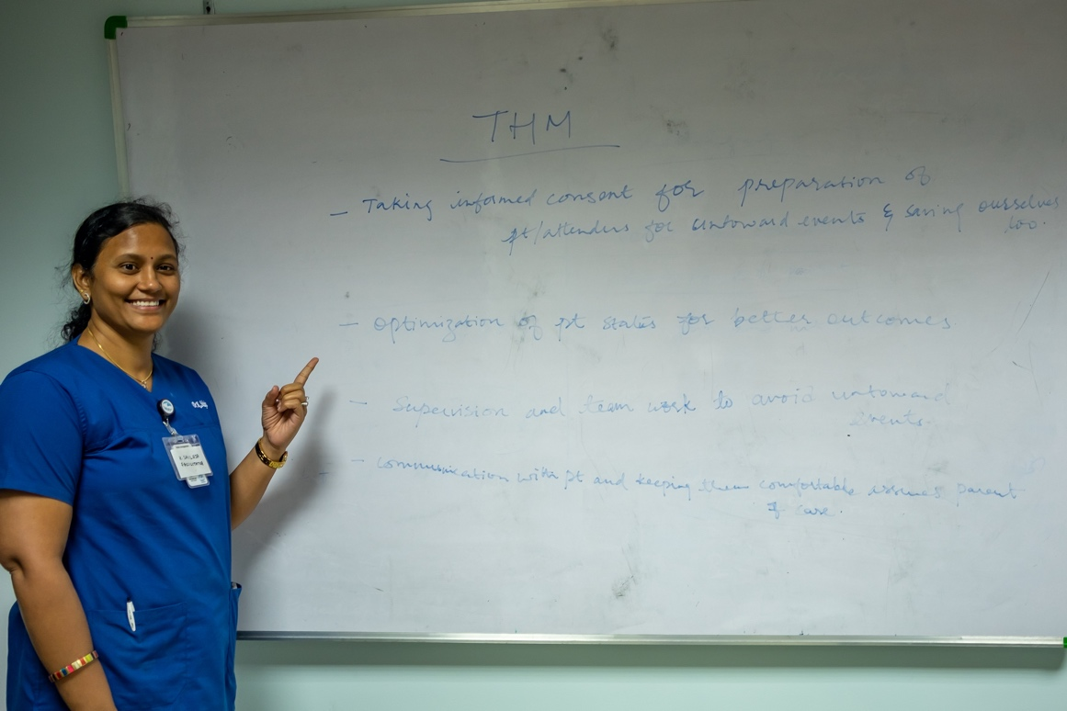

Sailaja is extremely proud of the take home messages (THM) the
group has generated

Gita reviews the VAST debriefing framework
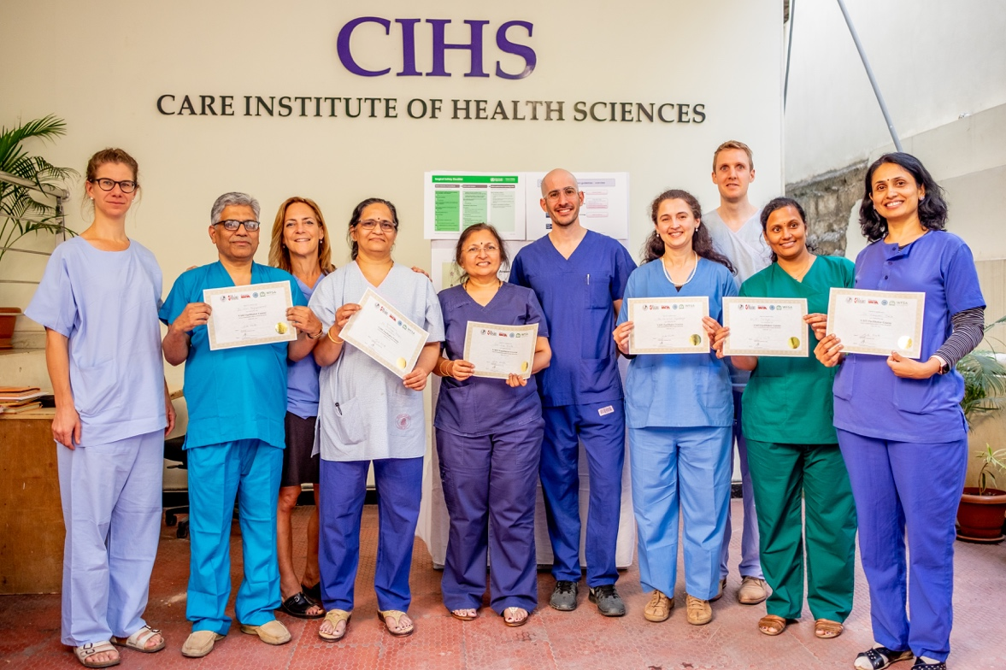

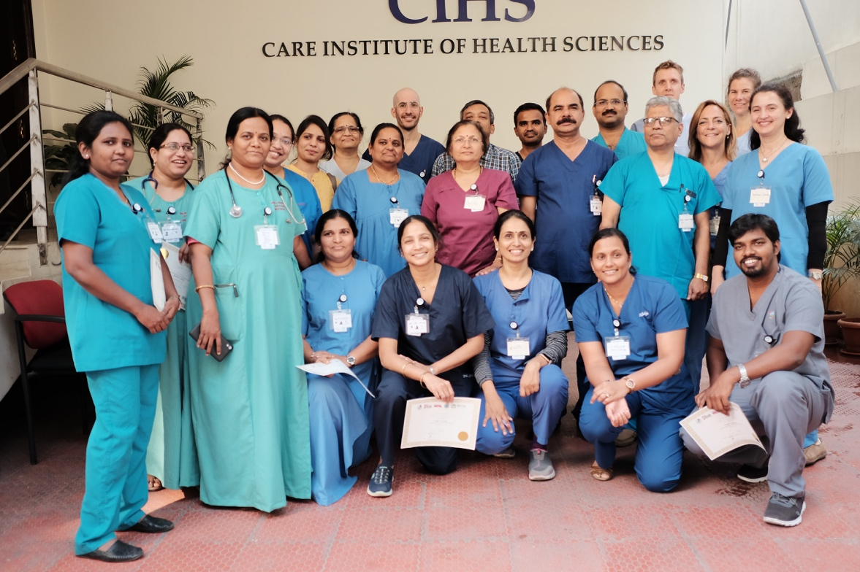

Top left: The Prof gets involved in neonatal
resuscitation

Top right: VAST FC certificate presentation

Bottom right: VAST Course certificate presentation

